Monash University Student Association
3rd MSC Meeting 2017
Business Paper

- Acceptance of Apology and Proxy Letter
  - Sean Liew is unable to attend today’s meeting as he will be attending his church’s training program from the 3rd of March to 5th of May. He grants his voting right to Bu Min Yee.

  - Shaun Prakesh Stanley is unable to attend today’s meeting as he will be representing Monash University Malaysia in the Asia Cheerleading Invitational Championships 2017 at Singapore. He grants his voting right to Mohak Nanik Bhambhani.

- Acceptance of 1st and 2nd MSC Meeting Minutes

President’s Report

Date: 29th March 2017
Attention: All departments/Divisions

Purpose: To inform

Operating hours of the University and MUSA

- MUSA office/University normal operating hours: 6am-12am
- MUSA office air-conditioning hours: 8am-12am
- Should MUSA members need to access and utilize the office for periods outside the stipulated times, an email to the President is to be sent, to update the relevant parties.

Cleanliness of the office

- President has received complaints from students and fellow MUSA members that the MUSA offices are not kept in good conditions.
- The MUSA offices and common areas are to be kept in an appropriate manner at all times.

Printing quota

- Better use of the resources being allocated to the MUSA.
- Each department is to receive RM 200 per member.
- Should each department have insufficient funds for that particular month, an email to the President is to be sent and additional funds will be added to that account.

Discover Monash Day (DMD)

- MUSA Treasure Hunt received amazing support and good feedback from the University and participants.
- Parade of Nations very well exhibited the diversity of our campus.
- Overall, the University has expressed their gratitude to MUSA for their support and assistance during the event.

MuMeds and MUSA Collaboration

- MuMeds and MUSA will be collaborating to do a charity run in Semester 2, 2017.
- This will be spearheaded by the School of Medicine and Health Sciences Representatives and Vice Presidents.

MPA President

- President has contacted Mr. Peter Hurley to discuss representations of MUSA on the Australian platforms.
- The matters that are to be discussed are:
- Feasibility of appointing and independent staff member for the MUSA.
- Recognition of MUSA within the University Regulations and University Council.
- Further update on the request of the President to be involved in the Thrice Yearly Student President’s Forum with the Vice Chancellor.

Activities Advisory Committee (AAC)

- All events especially major ones need to be discussed with the AAC.
- The AAC will be able to provide a neutral perspective of the challenges to be expected for each event.
- The AAC will discuss with the President on the major events on campus.

Certificates

- The MUSA Editors will be working on the MUSA Certificates that are to be printed.
- Guidelines revolving that will be disseminated once finalized.
- Discussion is underway with the University regarding this matter regarding the legal locus to print certificates.

OHSE

- Activities, Welfare and C&S, are to coordinate a date to be briefed by OHSE on risk assessment.

MUSA FORUM

- Wednesday (Week 7) from 3pm-6pm at the University foyer.
- All MUSA members are to attend the FORUM or at least send a representative of that department in order to provide clarification to the student population if need be.

Subcommittee help and issues

- There is a total of 130+ subcommittee members for the MUSA 2017.
- President advises that each department to allow each and every subcommittee member to contribute strongly to their department and to MUSA.
- Should any department require assistance for their event or planning of their event, a request on the “MUSA Official” WhatsApp group is to be sent.
- President strongly believes that the subcommittee members have the potential to push MUSA to greater heights and it is with their input can we make 2017 a successful year.
- Subcommittee members will be getting their T-shirts soon as the designs have been chosen and we are currently searching for a feasible supplier.

Collaboration with Radio Monash

- As proposed in December 2016, we are working to collaborate with Radio Monash to cater to different students’ interests.
- First interview was conducted on the 29th of March 2017 from 12pm-1pm.
- Matters discussed were:
- Events such as RUN, MCN, Monash Cup, MUSA FORUM
- Communication between students and MUSA is key.
- Tough decisions will be made in 2017 for the betterment of MUSA and Monash
- Trust MUSA will do all it can to be the bridge between the students and the University
- Students need to voice out their concerns through the right channels.
- “Help us help you”
- President will be working with the University to discuss the feasibility of installing speakers in prominent areas for Radio Monash to broadcast their shows.

Collaboration with International Think Big Summit

- 10th June 2017 at Taylor’s University Lakeside Campus.
- “Think Big, Think Different and Why Should We Even Care”
- Psychology, Science, Physics, Education, Entrepreneurship, Morality
- MUSA’s contribution:
- Promote to Monashians via social media platforms
- Share event page
- Post A3 posters around campus to promote event

- Summit’s appreciation:
- Include MUSA’s logo in website, booklets and e-posters
- Offer special promo codes for Monashians

Movie tickets promotion

- President will be communicating with the cinema outlets to strike a deal for MUSA to purchase the tickets at a discounted price.
- This is because Movie Nights are prevalent and is a hit at our campus and it is best we utilize this as a platform to negotiate with the cinema outlets.

CIMB project

- Be$MART program consists of interactive lectures, simulations and Q&As with CIMB Bank to provide financial literacy to university students.
- It is a 2-day workshop.
- General Secretary will be determining the feasible dates to conduct this program on campus.

Food outlets

- There have been a few proposals brought forward to bring new food outlets to Monash.
- Please channel any suggestions regarding this initiative.
- Details that we will be looking into are:
- Existing operator in a different location
- Name of outlet
- Halal certified?
- Location on campus
- Have had prior discussions with vendors
- Will be discussed with Mohak Bhambani (MUSA representative for the Food Services Operations Committee)

Treasury procedures

- President, Treasurers, Heads of C&S and C&S Treasurers will be discussing financial guidelines and procedures for the approval of funds for clubs and societies on campus.
- Request for the Heads of C&S to disseminate the information to all clubs.

TEDxMonash

- The team for this year includes:
- Vice President
- School of Business
- School of Science
- School of IT
- School of Medicine and Health Sciences
- Vice-Presidents will be coordinating meetings to discuss this further before applying for the license.

Sport facilities at Monash

- Every semester the University conducts their upgrades on the facilities on campus.
- Issues have been raised regarding the condition of the sports facilities.
- FMD has looked into the matter and have worked on the following:
- Replacing of basketball rings
- Painting of goal posts
- Artificial turf area will be re-done tentatively in May 2018 in line with the Campus Masterplan.

Football for Monashians!

- Students have approached regarding their interest in playing football.
- President and the University has come to an agreement with Sunway University to allow Monashians to play this sport at their field.
- Finalized details will be disseminated soon.

Cricket for Monashians!

- University has decided that outdoor cricket is not allowed on campus as there are various safety considerations that have to be taken into account.
- President, however is working with OHSE to assess the risk of indoor cricket and possibly allow indoor cricket to be played on campus.
- President is working with the University to contact Taylor’s University Lakeside Campus to allow Monashians to play outdoor cricket at the Taylor’s grounds.

Official LLC Statement

- The official statement released on the 21st of March 2017 on the FB page received tremendous feedback.
- As many students inquired why the LLC had come to the conclusion, a statement was released to address exactly that.
- The MUSA is not agreeing or disagreeing with the University. Feedback and discussions are underway to channel the constructive feedback to the University.

Standard Operating Procedures (SOP)

- Several attendees of the 2nd MSC highlighted their concerns regarding the lack of dinner being served as compared to the serving of light refreshments during MSC.
- There exist business rules and the campus has rules with regards to food being served during meetings.
- “Catering services for events and meetings for staff should be confined to the provision of tea, coffee and cold drinks only.”

- “Lunch is not normally provided at an event less than four hours long”

MUSA members feedback on social media

- Codes of Conduct as per stated in the 1st MSC:
- Any conflict faced by MUSA members need to be resolved in a professional manner and brought to the President’s attention and in no circumstance, be blown out of proportion.
- Discussions as per stated in the 2nd MSC:
- Have I communicated this issue to the right person through the right channels?
- What would I do if I were in his/her shoes and have I given him/her the benefit of the doubt by advising on my opinions?
- Why do we actually do what we do and could this be changed for the better?
- Who in my team can I ask for help and is in the best position to help me out?
- Several MUSA members have ignored the Code of Conduct and not conducted a self-reflection for themselves.
- Under no circumstance does a MUSA member defame, undermine and tarnish the name of MUSA.
- Any further actions that violate these guidelines will result in a warning letter being issued and further action taken.

Contributed by,

Janesh Nathan
President
Monash University Student Association.

Vice President’s Report

Date: 31th March 2017
Attention: All Departments & Divisions
Purpose: To Inform
- Subsidy
  - Langkawi International Maritime and Aerospace Exhibition 2017
- Exhibition is from the 23rd of March – 25th of March 2017.
- Total of 40 engineering students attended the exhibition.
- Total expenses was RM8,380.00.
- Subsidy approved is 50% of total expenses (RM4,190.00).

  - School of Pharmacy Australian Medicine Handbook.
- Total of 99 books sold.
- Students paid A$150/per book.
- Subsidy approved is freight cost (A$1,350.00).
- After conversion is (A$1,350.00 * 3.5 = RM4, 725)

  - Shell Eco Marathon Asia 2017 Competition
- Competition was held on the 15th of March – 20th of March 2017.
- Total of 18 participants attended the competition.
- Total expenses were RM26, 628.00.
- Subsidy approved is 60% of total expenses (RM15, 976.80).

- Discover Monash
- The Open Day was on the 18th of March 2017.
- It was a collaboration with Activities Department of MUSA.
- A total of 24 helpers which comprised of MUSA members and subcommittees.
- A campus hunt was organized with 6 different stations located at the new cafeteria, umbrella area, multi-faith center, gazebo and futsal court.
- For participants that took part in the hunt, they were given Monash merchandise that was provided by the Marketing Department.
- A “Parade of Nations” was organized by MUISS department. President of MUSA joined it accompanied by one Chinese, one Indian and one Malay.
- Overall, the Open Day was a success and admins appreciated MUSA’s contribution.
Prepared by,

Vandana M Suresh Kumar Ratnani
Vice President
Monash University Student Association

General Secretary’s Report

Date: 31st March 2017
Attention: To all Departments and Divisions

Purpose: To Inform

- By Elections

- By-Elections officially ended on the 15th of March 2017.
- Results were released on the 15th of March at 9am on the Official MUSA Facebook Page.
- Nelson Wong Wei Han has been appointed as the Male Representative of School of It for the year 2017.
- Simran Kumar and Asma Tabassum have been appointed as the Treasurers for the MUISS Division
- Shusruto Rishik, Shevyn Marshall, Manik Bhooshan Rege, Shahla Rakshana Ziath have been appointed as the Editors for the MUISS Division. However, due to unforeseen circumstances, Shahla Rakshana decided to pull out of the committee and has sent in her resignation letter.
- The MUISS positions were uncontested whereas the Male IT Representative was contested.
- Breakdown of results;
Name | Vote | Percentage | Total Votes | Total Abstain
Nelson Wong Wei Han | 23 | 53.49% | 43 | -
Ng Chung Hou, Skyler | 20 | 46.51% | 43 | -

- Full report is available for viewing should anyone be interested to have a look.

- Warning Letters

- Warning letters have been issued to certain members in the last few days and they include both the Activities Chairperson.
- Departments are to remember that deadlines are set for a reason and failure to adhere to deadlines will result in the issuance of warning letters, depending how severe the case is.
- Warning letters are also to be issued should the Executive Committee and/or President himself feel that there is an obstruction in the way things are carried out on a day to day basis.

Contributed by,

Priyanka A. Subramaniam
General Secretary
Monash University Student Association

Clubs and Societies Report

Date: 31th March 2017
Attention: All Departments & Divisions
Purpose: To Inform

1.) C&S Week
- Total of 62 clubs had booths around the foyer as well as carpark area
- Officially 53 clubs under C&S
- All official clubs set up their booths other than Motor Sport
- Performances by Street Dance Club, Dance Fusion Club, Cheerleading Club, Rock-climbing Club, Music Club, Chamber Orchestra and Aikido Club
- Best Booth Award won by Monash Animanga Club
- Runner up is Monash Performing Arts Club
- Third place is Monash Christian Fellowship

2.) Email and EMR Updates
- Most of the clubs have access to the online EMR as well as their official emails
- Only the clubs with new emails have yet to receive their network ID
- Hard copy EMR will be sent in by us manually and booked through FMD and Welfare Officers respectively

3.) Opening Ceremony and Banner Dropping
- Held on the 23rd of March at 12pm in front of cafeteria
- Opening Ceremony began by a speech from the MC
- Special thanks to Samuel Goh for helping us out by becoming the MC
- Performances by Street Dance and Cheerleading
- Dropping of banners

4.) House Election
- Held on the 29th of March from 6-8pm at the basement lecture theatres
- Sports Briefing and brief introduction of Monash Cup
- To choose the new house committee for Monash Cup 2017
- Elected house committee will be responsible for the entire year
- Food was provided

Contributed by,
Lai Kai Bin and Cheong Wei Yang
Head of C&S

MUISS’ Report

Date: 31st March 2017
Attention to: All departments & divisions
Purpose: To inform

- Social Night
  - The event was held on Wednesday,8th of March.
  - In collaboration with ISS.
  - Expecting 100 people, 200 signed up.
  - Therefore, space and food was an issue.
  - The event showed potential for such events in the future
  - Thanks to VP for providing the mats.

- Holi
  - The event was held on Wednesday, 22nd of March.
  - Due to delay from facilities, it was advertised at the last moment.
  - 138 of 150 people signed up, out of which about 80 showed up.
  - It was a success, people gave good reviews regarding the event and food.
  - No major damage done to the property.
  - Thanks to Musa members and sub-coms to come out and help us.

Contributed by,
S. M. Mohsin Ali
President
Monash University International Students Services (MUISS)

Wom*n’s Report

Date: 31 March 2017
Attention to: All departments & divisions
Purpose: To inform

1. International Women’s Day
1.1. Theme: Domestic Violence
1.2. Purpose: International Women’s Day serves as a day for everyone to celebrate the social, cultural, economic and political achievements of women, as well as a call to action for gender equity. Thus, it was decided that we should recognise and acknowledge a gender issue that is significant yet often hidden, especially in the context of Malaysia – Domestic Violence.
1.3. What did the event entail?
1.3.1 Booth set up just outside of the library, complete with 3 boards used to put up banner and posters contributed by Women’s Aid Organisation (WAO). Video pledges were also recorded. Students and/or staff who did a video pledge were given a white ribbon and a free cupcake each.
    - Banner: Students as well as staff signed and wrote down messages in relation to domestic violence (i.e. support for domestic violence survivors, written pledge against domestic violence)
    - Video pledge: Compile all the video pledges into one video, with intentions of sharing it on MUSA Facebook page as well as on the social media accounts of All Women’s Action Society (AWAM) and WAO should they wish to share the video.
    - White Ribbon: Symbol of opposition to Domestic Violence/ Violence against women.
    - Cupcakes: Token of thanks.
1.4. Outcome: 170> video pledges, 200> signatures
1.5. Remark(s): Even though we had expected to have more video pledges/signatures, we are very pleased with these numbers because we realized that the number of video pledges (170) we had did not equate to the number of people who took their pledge since there were a lot who chose to take the pledge in a group or with a partner.

Contributed by,
Jasmine Gomez
Women’s Officer

Verified by,
Hannah Reshma Jambunathan
Women’s Officer

Publicity’s Report

Date: 31st March 2017
Attention to: All departments & divisions
Purpose: To inform

- Revival of the pantry

- Require RM 1000 to initially clean up the pantry and reincarnate it.

- The breakdown is as follows:

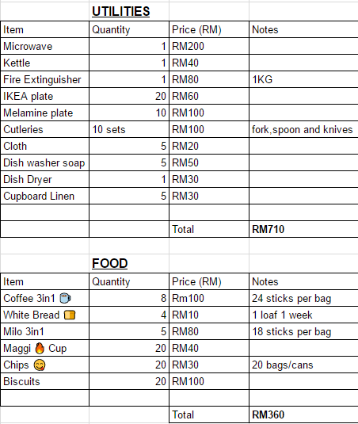

- In subsequent months the funds that are required would be only be used to stock up food and beverage.

- Strictly for MUSA Committee members and subcoms only.

- Security measures: Usage of fridge lock and cabinet locks would be used.

- Reason of initiative: As a MUSA member, we work tirelessly and most of our time is spent in the office. A small perk like this would definitely enlighten everyone in the long run. NO MORE HUNGRY & ANGRY PEOPLE.

2. Facebook Promotional Boost

Preview of Ad on Dekstop/Laptop

- MUSA Facebook Page

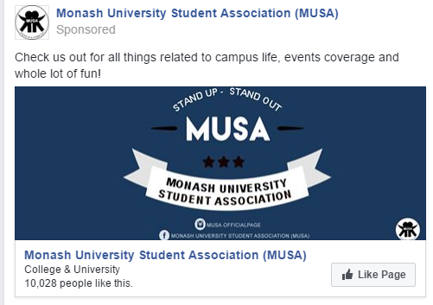

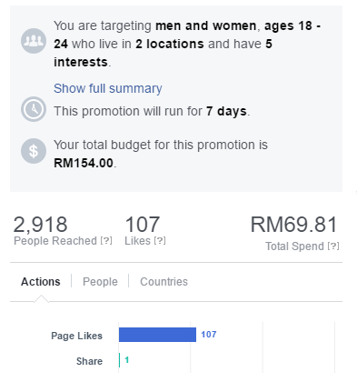

- Data above is from 25 March 2017

ii. C&S Division Post

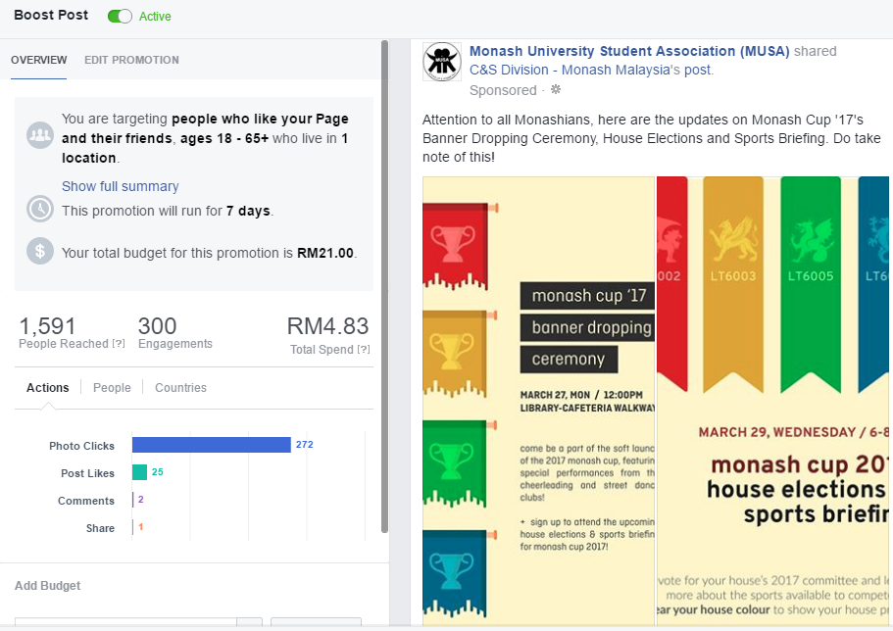

Contributed by,

Shaun Tan
Publicity Officer

Editor’s Report

Date: 31st March 2017
Attention to: All departments & divisions
Purpose: To inform

- MUSA MONGA
- Covered 26 events (as of 24th March) (24, for 2014, 33 for 2015, 15 for 2016)

- FACEBOOK DATA
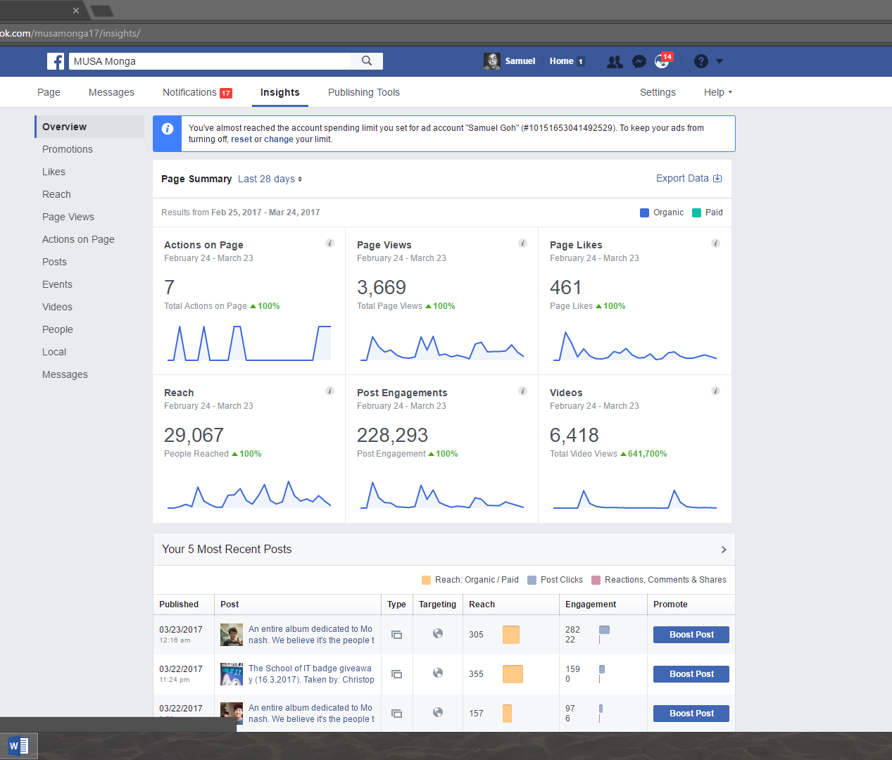

- WEBSITE DATA

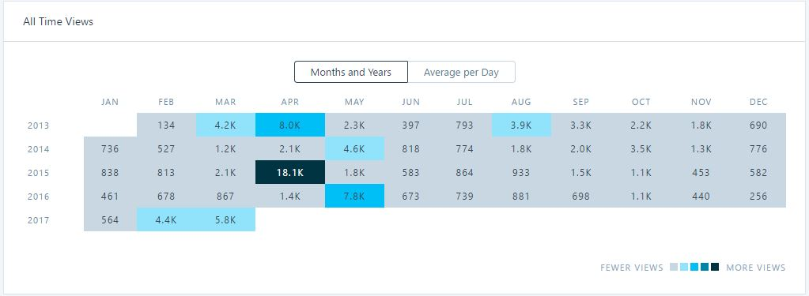

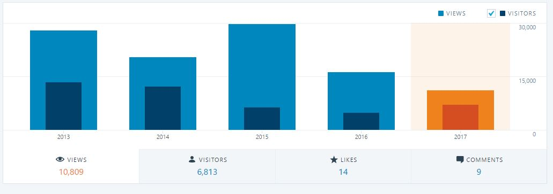

- Subcommittee
  - 21 subcommittee (8 writers, 13 photographers/ video, w/ 2 volunteers.
  - Photographers spilt into 5 teams with a minimum of 2 events covered a week PER team.
  - Writers report on events on a turn-by-turn basis. Each writer is also expected to write at least 2 lifestyle-related article of their choice each semester.
- Thematic Competition
  - Planned to be held 6 times a year, 3 times per semester, 1 time each month.
  - The themes are related to different aspects of life and imagination – this month, it is Fantasy.
- Collaboration with Radio Monash
  - Help in the promotion of each platform – interview the editor of Radio Monash blog.
  - Work on different activities with Radio Monash.

School of Engineering’s Report

Date: 31st March 2017
Attention to: All departments & divisions
Purpose: To inform

- Buddy-Buddee Night

- Date : 16th March 2017 (Week 3, Thursday)
- Time : 6.00pm - 9.30pm
- Venue : Library Rooftop Level 4
- There were a total of 167 students whom attended this event.
- The event started on time, at 6.45pm. However, due to the punishments from ice breaking game, the time was delayed for about 15 minutes, thus the time for the following games were shortened to get back on schedule.
- 76 pizzas were served and there were no leftovers.
- Everybody enjoyed the event and the feedbacks from a few of students were the games were more interactive.

- LIMA Airshow
- 40 students participating in this field trip.
- Date : 23rd March 2017 – 25th March 2017

Contributed by,
Terry Lee & Loh Jun Mann
MUSA School of Engineering

School of IT’s Report

Date: 30th March 2017
Attention to: Everyone
Purpose: To inform

To inform | To inform council members on the Garena Student Alliance

- Garena Student Alliance
  - Garena Malaysia has approached School of IT to be a part of Garena Student Alliance (GSA)
  - School of IT has approved as of 22nd February 2017 to be a part of GSA
  - Members in GSA (Monash) comprises of School of IT Representatives and the sub-committees.
To inform | To inform council members on SoIT previous event(s)

- School of IT Badge Giveaway
- Around 60 badges were given away on the Thursday, 16th March 2017
- Remaining 85~ badges, reserved for July and October intake
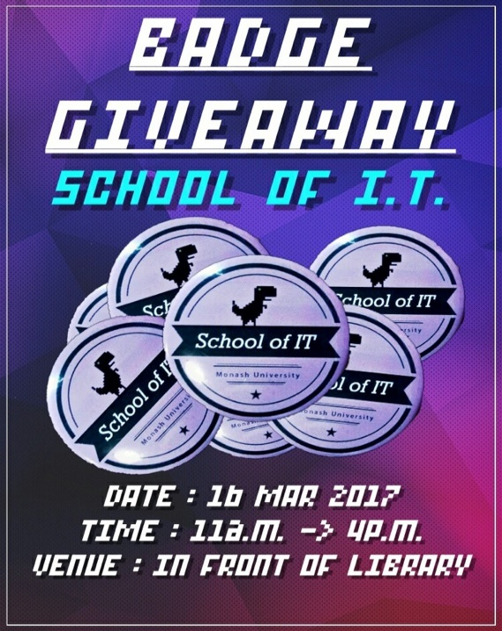

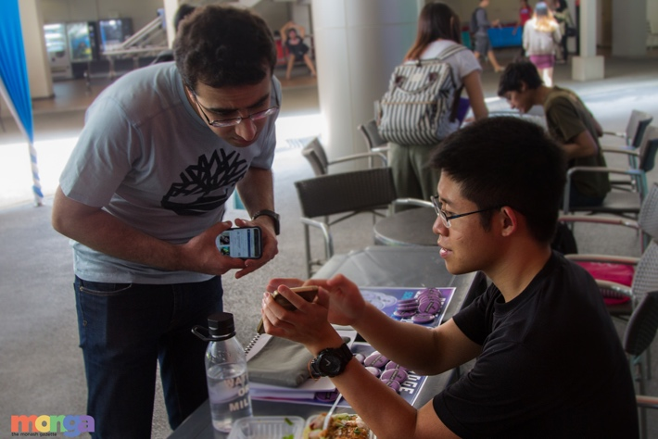

To inform | To inform council members on SoIT ongoing event(s)

- School of IT T-Shirt Design Competition
- Submissions for the t-shirt design competition are now open until the 7th April
- Winner will be given free t-shirt and RM150 voucher
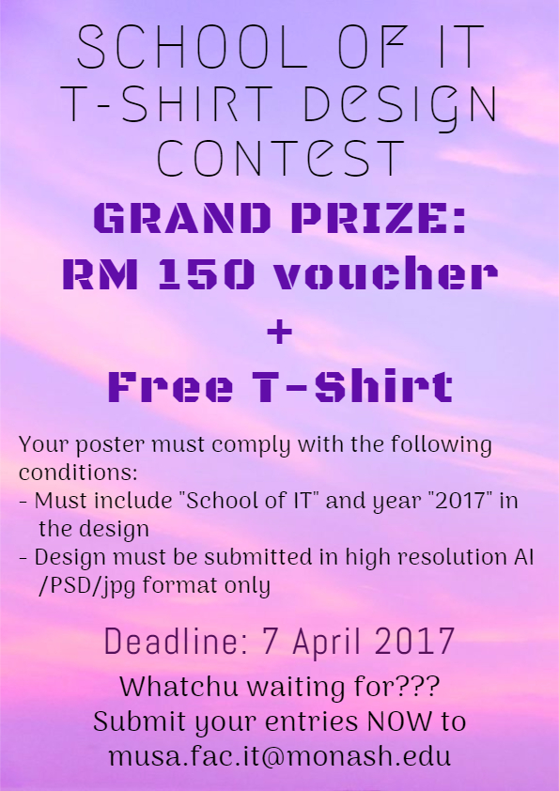

Contributed by,
Nelson Wong Wei Han & Nur Hidayah Binte Azhar
School of Information Technology Representatives

School of Business’ Report

Date: 31st March 2017
Attention: All departments & divisions
Purpose: To inform

- Staff Student Liaison Committee (SSLC) Meeting (20th March 2017):

- Response Form
- Forms were handed out respectively to students from each unit across Year 1 to Year 3 subjects.
- Feedbacks & Suggestions are gathered base on lecture hack where hard copy forms were given out to students.
- Electronic form is also promoted & available through our social media platform – Monash School of Business (SOB) page.
- Contents have been brought up in the meeting and admins are in the midst of coordinating each of the constructive problems students brought up to each unit and lecturer.

- Main Meeting Agendas

- Video Lecture
- Majority of students have brought up the issue
- Video slides are not utilized or implemented on a rate where students would wish to see
- Students find it extremely effective as a form of teaching method especially for programming units
- The committee was pretty much powerless and seemed reluctant and dismissive in terms of the implementation.
- Admins argued that it discourages students to attend physical lecture/ Not all lecturers have enough resource to purchase the laptop with the relevant technology for video slides/ It takes too much of their time and theres no rewards given.
- We pushed for complementary video lecture and unit related educational video and to only upload towards the last two or three weeks of final.

- Information in Unit Guide not Synchronizing with the one on Lecture Slides
- Lead to confusion
- Students will be unsure of the actual content
- Assignment submission dates and date for test not aligned
- Coordinators are willing to take immediate actions into it.
- We started an initiative from google form to collect date, received zero responses.
- Either we are not targeting enough students or lecturers this semester are doing phenomenal.
- Going into week 6, requesting all school of business students under the student council to spread the initiative and to be our ears in terms of collecting and let known to other business students to fill up.

- Internet connection across Building 6
- Building 6 is School of Business Building
- Weak internet connection makes it hard for students to access email/ allocate/ or their study material

- Committee was pretty much powerless. Problem will be addressed in the next Facilities Education Committee (FEC) in School of Business.

- We were informed by the Committee that theres other platform where representatives from MUSA would go for. Any other platform to discuss internet/ video slides/ discontinuation of lap top loaning service?

- Finance Seminar
- Held in Week 4 (Thursday, March 23rd)
- Conducted by Fiavest Academy
- Seminar was focused on the stock market particularly, emphasizing on tradings & investments.
- Slots were opened for 50 students, 45 signed up, 40 attended.
- Food were sponsored by the Education Office
- Feedbacks were gathered from some students: some stated that the speaker failed to communicate the message clearly; some stated that the content was complicated and hard to understand.
- Overall, the seminar went smoothly.

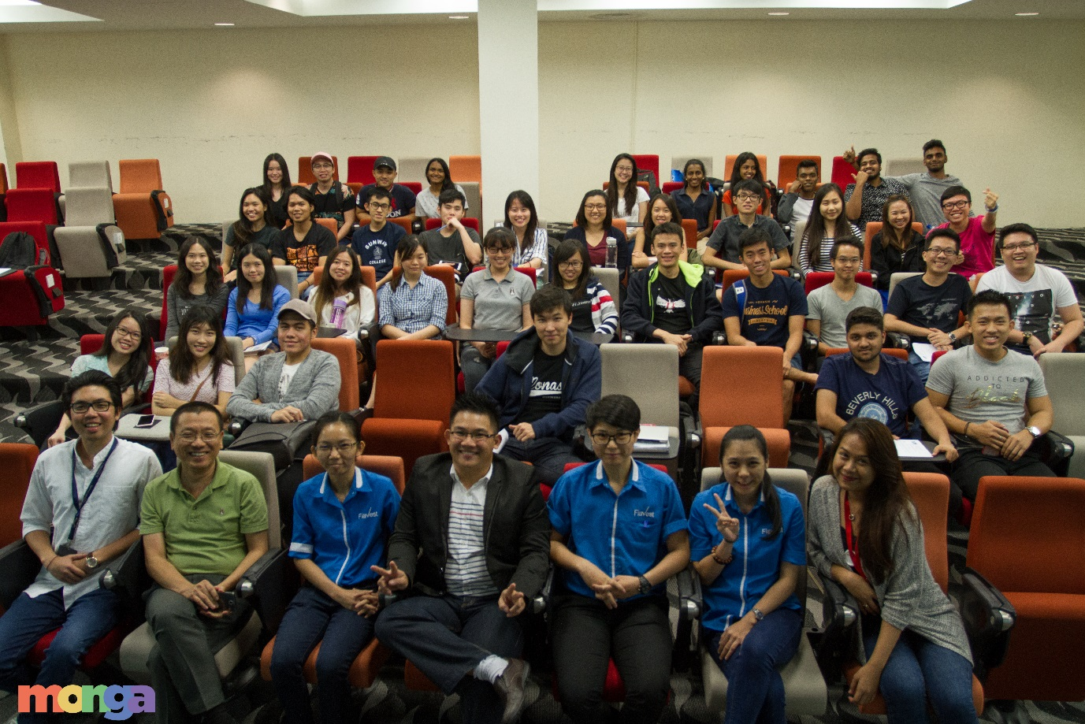

- T-shirt design competition
- Week 4 to Week 5
- Design(s) will be posted up on Facebook for students to vote
- Winners will be rewarded with a gift card worth RM150
- T-shirt order will be opened on a pre-order basis, tentatively in week 7

- Collaborations with business clubs
- We have approached MEC, MBC, MAFC and MUIG to propose our idea to collaborate with them for our upcoming events
- Discussions are still ongoing
- As of now, we will be collaborating with MEC for SOB A-Fair & iEntrepreneur;
- These two events will be combined into one event in Week 9
- Advertising costs & revenue earned will be shared
- Currently working on ideas on how to ensure that vendors work on their marketing & promoting skills as the purpose of the event is to unleash the creativity & entrepreneurial side of our students
- This event will be open to students from ALL schools (with respect to a significant amount of MEC members that are non-business students) – however, business students will be prioritized

Contributed by,

Pang Kai Teng & Nur Addina binti Kharmizi
MUSA School of Business Representatives 2017

School of Medicine and Health Sciences’ Report

Date: 31st March 2017
Attention to: All departments & divisions
Purpose: To inform

- Social Night
  - An event collaborated with MUMedS with School of Medicine and Health Sciences.
  - Main objective was to tighten the relationship between the Year 1 medical students and the Year 2s.
  - Itinerary of the day as below:

Time | Event
1630 | Preparation
1700 | Registration & Ushering
1730 | Welcome Speech from Pre-Clinical MUMedS President & Social Welfare Officer
1800 | Performance
1810 | Ice Breaking Game
1840 | Sorting of attendees into groups
1900 | Refreshments
2000 | Games
2030 | Performance
2040 | Games
2140 | Performance
2150 | Announcement of Winners
2230 | End/Clean up

  - Expected attendance was 150, final attendance 145.
  - Total expenditure unknown, MUMedS treasurer working on it.
  - Overall it was a great event, the objective of the event was met where the students had fun and got closer with each other.
  - One of the difficulties met was that the sound system in the badminton court had strong echo, which the voice of the emcee wasn’t clear enough throughout the whole event.
  - MUMedS had a feedback form for the students, the comments are all considered to improve events for them in future.

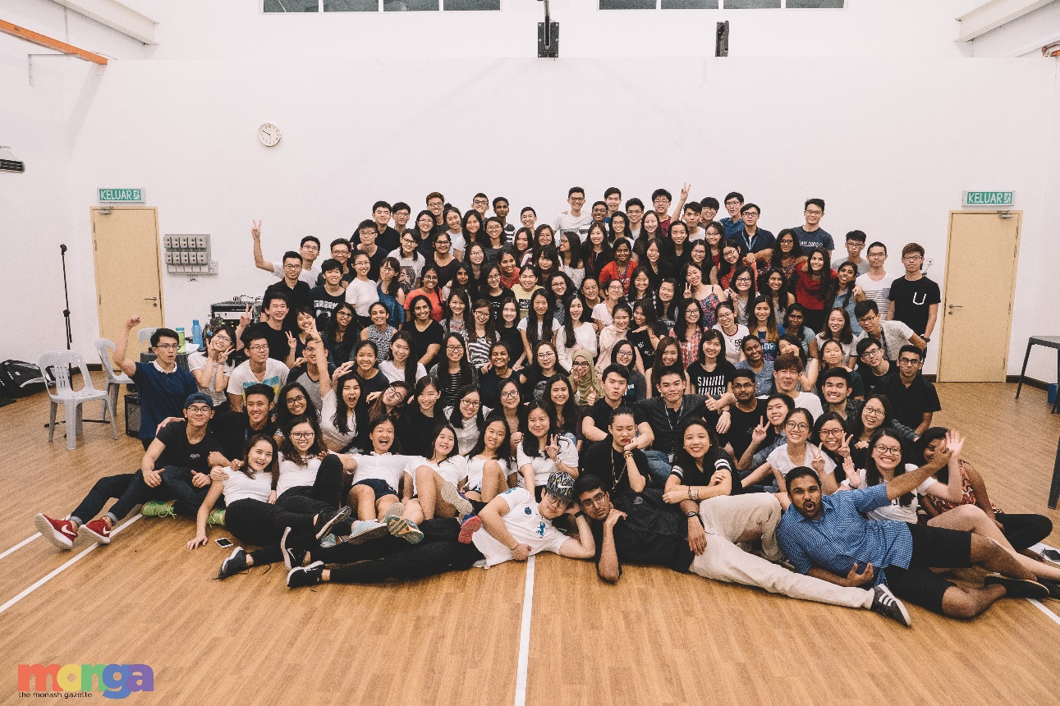

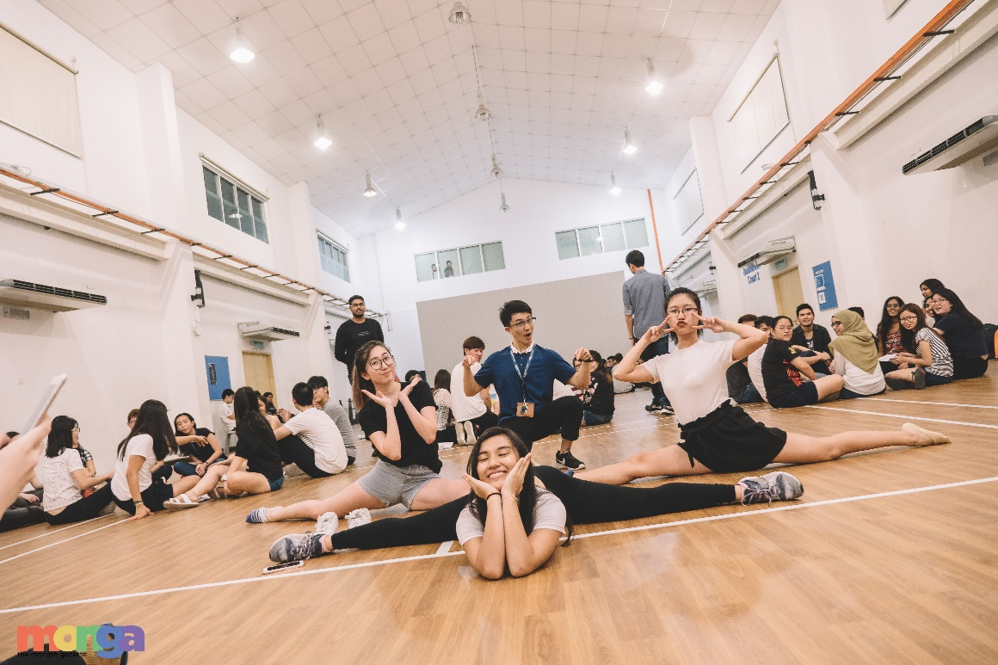

Contributed by,
Chong Tze Lin & Ejuin Woo
School of Medicine and Health Sciences Representatives

School of Pharmacy’s Report

Date: 31st March 2017

Attention to: All departments & divisions
Purpose: To inform

- Australian Medicines’ Handbook Purchase
  - A total of 99 books will be purchased.
  - We convey our thanks to the Vice-President’s Department for approving the subsidy of the freight charge.

- Subcommittee Recruitment
  - Approximately 25 students applied to be part of our subcommittee.
  - Out of the 25, 10 were recruited.

- Pharmacy T-Shirt Design Competition 2017
  - Status: Closed
  - We received about 20 submissions in total.
  - The representatives and their subcommittee will be picking 5 designs to qualify for a final round which involves voting by the Pharmacy students.

- Discover Monash
  - We planned and organized booth activities and an interactive tour for the School of Pharmacy.
  - 20 student helpers were recruited.
  - Despite the poor participation rate, participants reported positive feedback for both the tour and booth activities.

- Dodgeball Game (Thursday, 23rd March)
  - The School of Engineering, the School of Pharmacy and Jeffrey Cheah School of Medicine & Health Sciences co-organized a dodgeball tournament with the theme of “Star Wars: The Ball Awakens”.
  - The estimated number of participants was 96, with 32 from each school.
  - There were to be 12 teams of 8.
  - However, only 72 participants confirmed their attendance.
  - On the event day, only 65 participants showed up. We decided to have 11 teams of 6 to play.
  - We originally allocated RM794 for this event, but only spent a total of RM593.60. The expenses will be split among the schools equally.
  - Overall, the event went relatively smoothly and received positive feedback from the participants.

Contributed by,
Sean Liew Jia Xen & Yap Wuan Shuen (Serene)
Representatives of the School of Pharmacy

School of Science’s Report

Date: 29th March 2017

Attention: To all departments and divisions
Purpose: To inform

- PASS lessons signup
  - PASS lessons were promoted on O-Week during the School Representatives Briefing Session.
  - Peer Assisted Study Sessions classes begun in Week 3.
  - Classes will be on a weekly basis.
  - The units offered for Sem 1, 2017 are BTH 2741 (Biochemistry) and CHM1051 (Advanced Chemistry 1).
  - Students will have to go through the Science Course Management Office for signup. They can also contact Prof. Adeline Ting for any enquiries.
- Peer Mentor Recruitment
  - The Science Course Management Office has suggested to organize a Peer Mentor Program.
  - The program will consist of 5 mentors and 30 students.
  - The mentors will assist the students throughout academic Week `1 to Week 4.
  - The students can sign up with us by emailing us, and we will forward the list to the Course Management Office.
- SSLC Year Rep Recruitment
  - Year reps will be recruited as follows:
Year | Number of Reps
1 | 2
2 | 1 from Bachelor of Medical Bioscience  1 from Bachelor of Food Science and Technology  2 from Bachelor of Science
3 | 1 from Bachelor of Medical Bioscience  1 from Bachelor of Food Science and Technology  2 from Bachelor of Science

4. Recruitment of Sub-committee members:
  - Sub-committee recruitment forms by publicity were shared on the Monash University Malaysia School of Science group.
  - 19 responses were recorded; 5 sub-committee members were chosen.
  - Interviews were held in the MUSA discussion room between academic Week 2 and 3.
  - Names of chosen sub-committee members and their details were sent to Mr. President on 16th March 2017.

5. School of Science Movie Night:
  - Movie Night was held on the 29th of March 2017.
  - A poll was posted on the Monash University Malaysia School of Science Facebook group for students to choose the movie they preferred.
  - “Life” was the most popular choice.
  - A sign-up Google form was posted on the Facebook group for students to sign up for the event.
  - 50 responses were recorded. A waiting list was then put up. 8 responses were recorded from the waiting list. We had a total of 58 responses.
  - RM10.00 deposit was collected from each student. The deposit will be returned to them on the event day itself to avoid a low turn-up rate.
  - 52 tickets were bought from TGV Sunway Pyramid on 23rd March 2017. 50 tickets were sold. 49 people turned up.
  - RM10 will be revenue.

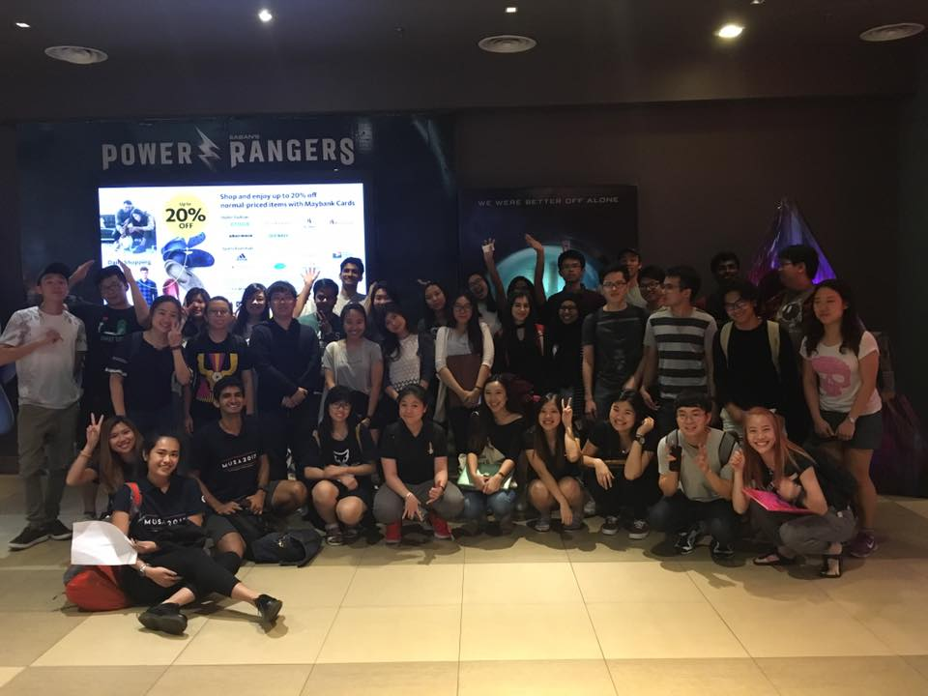

Prepared by,

School of Science Representatives
Jasvin Singh Cheema & Florence Tan Soo Suen

