Monash University Student Association
Monash Student Council (MSC)
3rd Council Meeting Minutes 2018

Date: 23rd March 2018 (Friday)
Time: 6.27 pm
Venue: MUSA Meeting Room, Level 2, Sports Centre

The following members of the council were present, constituting a quorum:

Voting Members

President: Thusharan Chandrakumanan

General Secretary: Tharshini Batumalai

Treasurer: Jaesivan Arumugam

Head of MUISS: Mazin Osama Hafiz Elshazali

Activities Chairperson: Ng Sie Mone

Welfare Officer: [Proxy] Kong Seng Kin, Terence

Publicity Officer: Milton Leong Hon Kin

Wom*n’s Officer: Melinda Anne Sharlini Damodaram

School of Arts and Social Science Joshua Wisely
Representatives: [Proxy] Lim Sue Yi

School of Business Soh Zu Peng
Representatives: Tiong Li San

School of Engineering [Proxy] Chin Desmond
Representatives: Crystal Thew Xue Er

School of Information Technology Ng Chung Hou, Skyler
Representatives: Clarissa Wong Yong Teng

School of Medicine and Health Nicholas Tan
Sciences Representatives: [Proxy] Esther Ong

School of Pharmacy Wong Choon Kwang, Raymond
Representatives: Bu Min Yee

School of Science Ethan Wong Hsien Aun
Representatives: Tan Yi Qi

Non-Voting Members

Treasurer: Kelly Lee Jia Yee

Head of Clubs & Societies: Nur Sharikul Huda

Head of MUISS: Hasan Habab

Publicity Officer: Trishadip Kaur Cheema

Wom*n’s Officer: Medha Mehrotra

Editors: Kong Seng Kin, Terence
Tuang Ling Jie
Chin Desmond
Elizabeth Louise Gerard

MUISS Secretary: Tasvir Hasan Majumder

MUISS Treasurer: Pranay Manchanda

MUISS Country Representative Charulatha Pitigala
Officer:

MUISS International Student Shafeeq Ahmed Syed Ali
Officer (Welfare):

MUISS International Student Ibrahim Jalal Ali Al-Kooli
Officer (Activities):

MUISS International Student Haider Jamal
Officer (Publicity):

Absent (With Apology)

Ryan Matthew Tang Activities Chairperson
Shaun Prakesh Stanley Welfare Officer

Dilhara Jayasinghe Welfare Officer

Leanne Lee Lyn Ai School of Arts and Social Sciences
Representative

Lim Rickque School of Engineering Representative

Rebecca Charmaine School of Medicine and Health Sciences
Representative

Absent (Without Apology)

Ng Chor Yee, Ryan Vice President

(Ng Chor Yee, Ryan is unable to attend today’s meeting as he will be representing Monash University Malaysia as a student delegate in the Australian ASEAN Education Dialogue taking place in Penang from 21st – 23rd March 2018. He will be deemed ‘absent without apology’ as he has submitted his apology and proxy letters on 20th March 2018 (past the deadline). Hence the letters were rejected.)

Ng Khai Tze Vice President

(Ng Khai Tze is unable to attend today’s meeting as she will be representing Monash University Malaysia as a student delegate in the Australian ASEAN Education Dialogue taking place in Penang from 21st – 23rd March 2018. She will be deemed ‘absent without apology’ as she has submitted her apology letter on 20th March 2018 (past the deadline). Hence the letters were rejected.)

Ashley Wong Lei Peng Head of Clubs and Societies

(Ashley Wong Lei Peng is unable to attend today’s meeting as she will be representing Monash University Malaysia as a student delegate in the Australian ASEAN Education Dialogue taking place in Penang from 21st – 23rd March 2018. She will be deemed ‘absent without apology’ as she has submitted her apology and proxy letters on 21st March 2018 (past the deadline). Hence the letters were rejected.)

Meeting Chairperson

Thusharan Chandrakumanan
MUSA Advisor

Mr Zebba

Student Representatives

Kristen Carlos School of Arts and Social Sciences

Nafisa Tabassum School of Arts and Social Sciences

Lim Tai Jie School of Engineering

Lim Sue Yi School of Arts and Social Sciences

Esther Ong Sze Shen School of Medicine and Health Sciences

Aaron Moses Vijayan School of Pharmacy

Looi Qi Wen School of Business

1. Acceptance of Apology and Proxy Letters

  - Lim Rickque is unable to attend today’s meeting as he has cheer rehearsal from 6pm to 8pm for his cheer showcase. He grants his voting right to Chin Desmond from School of Engineering. He has submitted his apology and proxy letters on 19th March 2018.

  - Shaun Prakesh Stanley is unable to attend today’s meeting as he will be organising Dry Run for MUSA Wars that will be held on 24th March 2018. He grants his voting right to Kong Seng Kin, Terence from School of Business. He has submitted his apology and proxy letters on 19th March 2018.

  - Dilhara Jayasinghe is unable to attend today’s meeting as she will be organising Dry Run for MUSA Wars that will be held on 24th March 2018. She has submitted her apology letter on 19th March 2018.

  - Ryan Matthew Tang is unable to attend today’s meeting as he has a family function to attend at 5pm. He has submitted his apology letter on 19th March 2018.

  - Rebecca Charmaine is unable to attend today’s meeting as she will be in Johor from 18th March 2018 to 28th March 2018 for her compulsory clinical rural placement. She grants her voting right to Esther Ong from School of Medicine and Health Sciences. She has submitted her apology and proxy letters on 18th March 2018.

  - Leanne Lee Lyn Ai is unable to attend today’s meeting as she is caught with high fever. She grants her voting right to Lim Sue Yi from School of Arts and Social Sciences. She has submitted her apology and proxy letters on 23rd March 2018 (past the deadline) but it has been approved as the reason mentioned was beyond her control.

Motion #1: Acceptance of Apology and Proxy Letters
Accepted by: Ethan Wong Hsien Aun
Seconded by: Jaesivan Arumugam

Motion #2: Acceptance of 2nd MSC Meeting Minutes
Accepted by: Jaesivan Arumugam
Seconded by: Kong Seng Kin, Terence

2. Office Bearers’ Report

2.1 President’s Report

Date: 23rd March 2018

Attention: To all departments and divisions

Purpose: To inform
    - Alliance
      - Met up with Presidents’ from Sunway University and Taylor’s University on 5th March 2018.
      - Had an hour long discussion with them to revive Alliance.
      - Many issues were brought up :
        - Commitment
        - Liability
        - Benefits to each campus
        - Timeline
(Student Association in Monash starts its term in January, student association in Sunway starts in May and student association in Taylor’s starts in October)
      - Taylor’s President is not too keen on the idea, as he wants to resolve the problems he has on his campus before creating a new committee.
      - Sunway’s President is willing to hear out more on the idea.
      - There’s no sense of commitment to the idea from Sunway and Taylor’s.

    - MUSA Rewards
      - A discussion with MEC took place two weeks ago.
      - Idea of collaboration was brought up, but nothing has been decided yet.
      - Talked to MONSU Caufield’s President and asked how it was done there.
      - Contacted FAVE via email, to get them to collaborate with MUSA for this reward system.

    - MUSA Feedback Form
      - The MUSA feedback form has been posted on the MUSA Facebook page.
      - The feedback will be collected at the start of every month.
      - The feedback will be sorted into groups and will be looked into.
      - Feedback will be outsourced to another department if need be.
      - A monthly status update will be posted up onto the MUSA Facebook page.

    - Printing Quota
      - If departments run out of printing credit which is RM200, it can be topped up by Mr.Zebba.
      - Printing credit is to be used wisely.

    - MUSA Week
      - MUSA Week is a new initiative to get feedbacks from students on various issues by approaching them directly at the common areas around campus such as foyer.
      - It will be held from 16th April 2018 to 19thApril 2018 (Monday – Thursday Week 7). MUSA Forum will be held on 20th April 2018 (Friday Week 7). Issues that were raised during MUSA Week will be addressed during the MUSA Forum.
      - Booths will be set up at the foyer during MUSA Week and it is compulsory for all MUSA members to be present at the booth and talk to students whenever they are free.
      - MUSA members are required to fill in the suitable time slot on an Excel Sheet and each department/division is required to fill in AT LEAST 4 SLOTS for the whole week.

(Student representative, Lim Tai Jie questioned the President on the outcome that is hope to be achieved from Alliance. Mr President said he would not be able to give a definite and specific answer as the goal consists of many factors such as students’ welfare, collaboration of events and etc.)

(Student representative, Lim Tai Jie questioned the President on the contribution of funds for Alliance events. Mr President said it will be contributed fairly by all the 3 universities but the contribution is not restricted to monetary contribution only.)

(Student representative, Lim Tai Jie questioned the President on the alternative use of the budget allocated for Alliance in the event if Alliance fails. Mr President has no answer for it as he hopes Alliance will work out as he is putting in a lot of effort and time into it. Mr President also added by saying if Alliance actually fails to work out, he will definitely inform the council members on the alternative use of the budget allocated.)

Contributed by,
Thusharan Chandrakumanan
President

Motion #3: Acceptance of President’s Report
Accepted by: Hasan Habab
Seconded by: Jaesivan Arumugam

2.2 General Secretary’s Report

Date: 23rd March 2018

Attention: To all departments and divisions

Purpose: To inform

    - MUSA By-Election 2018

      - Started officially on 26th February 2018 (Monday) and ended officially on 12th March 2018 (Monday). It was supposed to end on 9th March 2018 (Friday) but Monash University was closed down due to water interruption hence it has to be extended. Below is the exact timeline:
Nomination period: 26th February 2018 – 2nd March 2018
Campaigning period: 5th March 2018 – 8th March 2018
Polling period: 7th March 2018 – 8th March 2018
Declaration of results: 12th March 2018

      - By-Election Committee
Returning Officer: Tharshini Batumalai
Assistant Returning Officer: Lee Hsin Yee
Poll Clerk: Kristen Eugenie Carlos
Chew Yee Ling
Vote Counter: Kajendra Govindasamy
Shaailendraa Selavaraju

      - Positions contested:
MUISS Secretary (1 position)
MUISS Treasurer (1 position)
MUISS International Student Officer (Activities) (1 position)
MUISS International Student Officer (Publicity) (1 position)
MUISS International Student Officer (Editors) (2 positions)

      - Results:

Name of Elected Candidates | Position | Number of votes | Percentage per Total Number of Votes (%)
Tasvir Hasan Majumder | MUISS Secretary | 20 | 80
Pranay Manchanda | MUISS Treasurer | 21 | 84
Haider Jamal | MUISS International Student Officer (Publicity) | 20 | 80
Ibrahim Jalal Ali Al-Kooli | MUISS International Student Officer (Activities) | 20 | 80

Total number of votes: 25

      - All the candidates won uncontested.
      - Nominations were not received for MUISS International Student Officer (Editors) positions hence the positions will be left empty.
      - The final report of MUSA By-Election 2018 was submitted by the Assistant Returning Officer on 13th March 2018 and it has been approved by the Returning Officer on the same day.

Contributed by,
Tharshini Batumalai
General Secretary

Motion #4: Acceptance of General Secretary’s Report
Accepted by: Jaesivan Arumugam
Seconded by: Chin Desmond

(Tuang Ling Jie arrived at 6.43pm.)

2.3 Treasurers’ Report

Date: 23rd March 2018

Attention: To all departments and divisions

Purpose: To endorse

2.3.1 Audited report of MUSA 2017 Expenses
2.3.1.1 Auditing of the financial records of MUSA 2017 began on the 5th of
March 2018.
2.3.1.2 The report was finalized and submitted to the General Secretary of MUSA
2018 on the 19th of March 2018. The timeline of the process and the procedures that were done are as follows.
2.3.1.3 The official financial report from the Treasurers of MUSA 2017 was
obtained.
2.3.1.4 All financial records of 2017 were compiled. These included all monetary
movement from within MUSA to Monash Finance and also the recorded
expenditures from all 18 departments within MUSA. All relevant
documentation included.
2.3.1.5 All 18 departments were audited with reference to the financial records of
each respective department. The order of the auditing process are as
follows:
        - 5th March 2018 to 7th March 2018
- President
- Vice President
- Treasurers
- General Secretary
        - 8th March 2018 to 10th March 2018
- Welfare Officers
- Editors
- Publicity
- Wom*n’s Officers
        - 11th March 2018 to 13th March 2018
- MUISS
- Clubs and Societies
- Activities Chairpersons
- School Representatives:
School of Engineering
School of Business
School of Pharmacy
School of Information Technology
School of Medicine and Health Sciences
School of Arts and Social Sciences
School of Science
      - 14th March 2018
        - Summarisation and preparation of the official auditing report to be submitted to the General Secretary.
      - Auditing was concluded on the 15th of March 2018. Recommendations were given to further improve the financial system of MUSA. Report was prepared and signed by all the official auditors :
        - Yap Huey Xin
        - Dan Thomas George
        - Warren Lee Xiao Ming
        - Mok E Lin
      - Enclosed below is the Audited Report for MUSA 2017 Actual Expenses :

Overall, the financial report was presented in a true and fair view. The following are the suggested recommendations for improvement:

- Improvements in petty cash records for users to see the movements clearly and be able to match them with cash in hand.
- Consistency is needed in the documentation process to enable comparisons with past records.
- Ensure original documented evidence (eg: receipts) are photocopied before the ink fades if MUSA is allowed to only keep the photocopy version.
- All documents from quotations to payment voucher from Monash are compiled together to show the flow of funds for each event.
- Suggest MUSA to furnish all the committee members which are in charge of documentation with a guideline on the documentation structure.
- Ensure documentation is completed before submitting for audit to ensure a smoother auditing process.
- For each event, the documents should be in the same order which can show the simple and easy way to use them and gives a guide of how work is done and is easier for auditors to look for materials.
- Suggest MUSA to create an electronic version of all the documents and expenses which serves as a backup in case of any unforeseen event.

Thank you. 19th March 2018

Reported by,

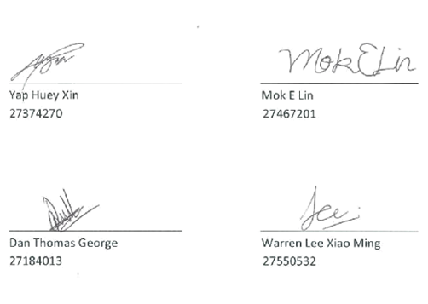

Motion #5: MSC to accept the Audited Report of MUSA 2017 Actual Expenses to be presented during MUSA Annual General Meeting 2018.
FOR: 20
AGAINST: 0
ABSTAIN: 2

(Motion is CARRIED.)

Contributed by;
Jaesivan Arumugam & Kelly Lee
Treasurers

Motion #6: Acceptance of Treasurers’ Report
Accepted by: Nur Sharikul Huda
Seconded by: Kong Seng Kin, Terence

2.4 Heads of Clubs and Societies’ Report

Date: 23rd March 2018
Attention: All departments and divisions
Purpose: To inform
    - Disciplinary actions
      - Several clubs were faced with disciplinary actions.
        - Monash Science Club and Monash Buddhist Society will be given warning letters for their absence at the AGM, despite signing the attendance sheet at the registration counter.
        - MuPhaS will be given a penalty for using pamphlets without approval from the C&S Publicity officer.
      - Claimed either the rules had been changed without their knowledge, or we [C&S] did not understand the rules.
      - First statement was obviously false, as they were all informed of rule changes during the AGM, along with the fact that the specific rule was in place since 2016.
      - C&S would prefer not to dignify the second with a response.
      - Overall, due to stricter rules and regulations, an increase in disciplinary penalties is predicted – a system that will stay despite the clubs’ displeasure.
    - Monash Cup
      - AGM scheduled to be on Wednesday, 21st March.
      - But now, it is being postponed, most likely to the 28th, because the previously decided date does not offer the ex-committee enough notice to begin recruiting.
      - Recruitment for players will begin from the 6th of April.
        - Will go on for a week – maybe more depending on feedback from houses.
      - Training will start from week 6, earlier than last year.

    - MBBS booth
      - Currently being applied for at the time of writing (ends on Wednesday, 18th March 2018).
      - Special booth set up for MBBS intake.
      - Progress report TBA after the week is over.

    - RBS issues and clashes with MUSA
      - Once again, must point fingers at the faulty RBS system.
      - Most recent issue: Engineering Buddy-Buddee night clashed with table-tennis and dodgeball practice.
      - Buddy-Buddee EMR went in first; however, the RBS system was not updated, leading to the double booking of training on top of the event.
      - Table tennis training was displaced to the lounge, courtesy of the charming Shaun Stanley ♥.
      - Dodgeball was cancelled for the second time, after clashing with the Futsal tournament earlier that week.
      - Cancellations and updating of the RBS has been a major concern
        - Yoga club had booked both badminton court on last Tuesday (13th March), due to their need for silence.
        - School of Business had, however, booked the courts both Monday and Tuesday, but the booking for the latter day was cancelled by SOB.
        - Despite the cancellation, the RBS STILL showed the court as reserved, and YET, students were able to book one of the supposedly reserved courts.
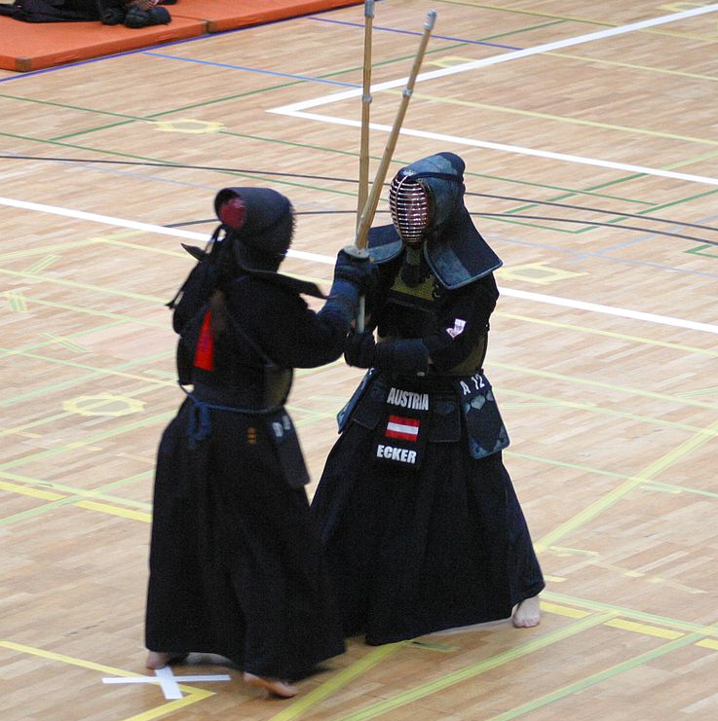
        - Long story short, yoga had to temporarily share courts with students fully dressed in uniforms and fighting with kendo sticks, and we had no idea why.

      - After the last meeting, Mr Zebba agrees that we need viewing permissions, and FMD is working with ITS to make that happen.
      - MUSA departments are requested to inform C&S in advance (preferably a week ahead) before reserving the recreational facilities.
        - This is to ensure we give clubs enough notice about displacing or cancelling their trainings/events beforehand.
(Head of Clubs and Societies, Sharik mentioned that C&S is projected to be broke by Monash Cup.)
(School of Information Technology Representative, Skyler Ng questioned Sharik on the reason. Sharik said Monash Cup is budgeted to cost RM 90,000. According to him, Vice Presidents have declined to give as much funding as they were for club activities that they were supposed to hence C&S has to adopt the responsibilities from the Vice Presidents. Vice Presidents were not present to clarify on this.)
(School of Information Technology Representative, Skyler Ng asked if the budget allocated for fixed subsidies for all clubs and societies will be affected due to the tight budget. Head of Clubs and Societies, Sharik said most probably not.)

Contributed by:
Ashley Wong Lei Peng & Nur Sharikul Huda
Heads of C&S

Motion #7: Acceptance of Heads of Clubs and Societies’ Report
Accepted by: Jaesivan Arumugam
Seconded by: Tan Yi Qi

2.5 Wom*n’s Officers’ Report

Date: 23rd March 2018
Attention to: All Departments and Divisions
Purpose: To Inform
    - International Women’s Day
      - Theme: Cyber Harassment
      - Purpose: It was noticed that cyber harassment is not seen as a serious issue and hate speech and cyber blackmail is very common these days taken that most of the people spend around 12-13 hours on technology every day. Therefore, the Wom*n’s Officers, decided to take a stand against cyber harassment and cyber bullying on this International Women’s Day (8th March, 2018)
      - What did the event entail?
        - We had a booth which was set up with 3 sets of comic strips and each strip focused on an incident relating to cyber blackmail, hate speech and stalking. In the center of the booth, we had a typical cyber bullying victim’s narrative.
        - Students came and pledged against cyber harassment and wrote on the post-its about Women’s Day in general. In return, they received a brownie with cards that said “Its on Us! To end cyber harassment”.
        - Pamphlets were distributed to people passing by which consisted of brief description of: What is Cyber Harassment? All the necessary information they need to know on Cyber bullying and a QR code which leads them to MCCHR’s (Malaysian Centre for Constitutionalism and Human Right) survivor kit which explained on how to survive and tackle situations of cyber harassment.
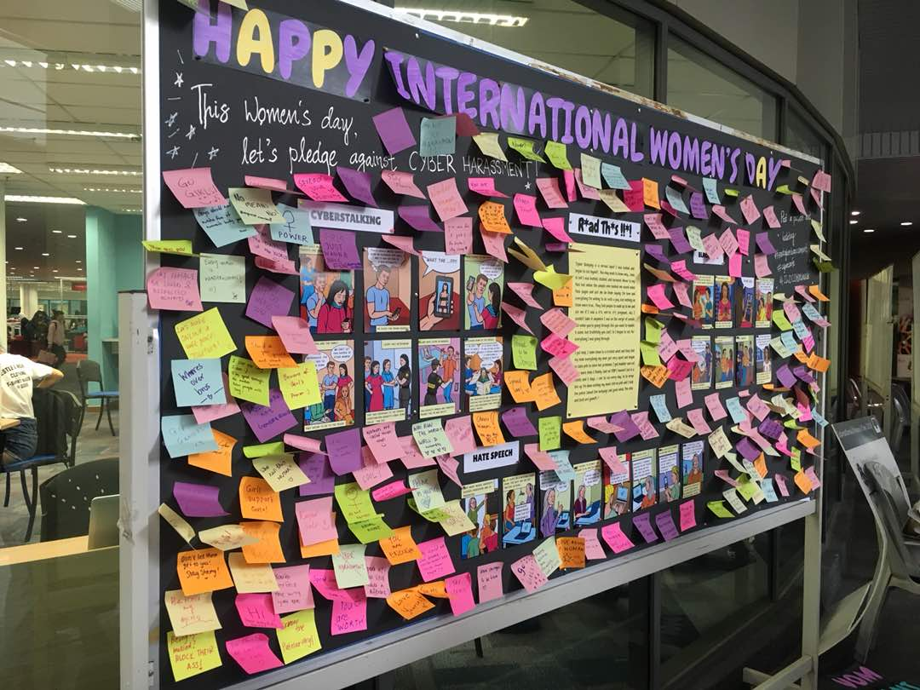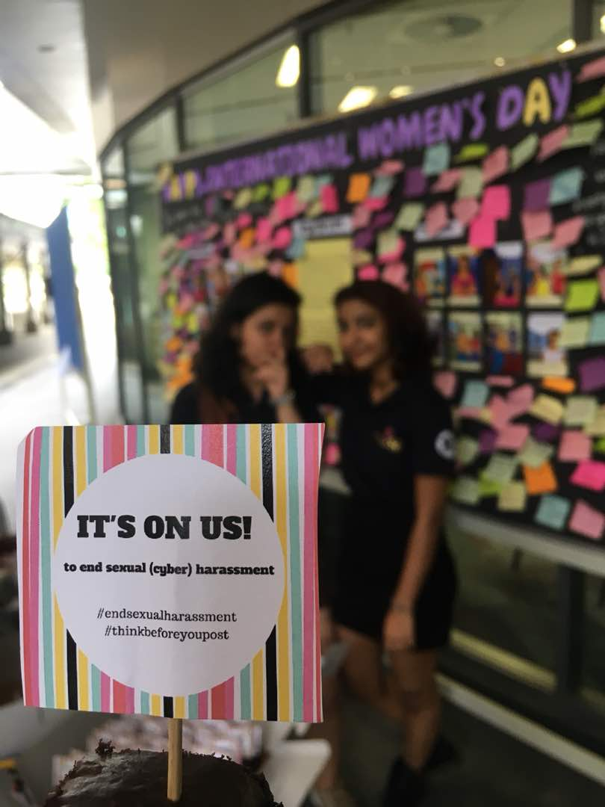
      - Video pledges: These video pledges were recorded in between 12-1pm and those will be compiled into one video with the intentions of sharing it on the MUSA page as well as the Women’s Affairs Collective page. Students who did the video pledges also received a mini badge which said “Its on Us! To end cyber harassment”.
      - The Wom*n’s Officers collaborated with MSDS (Monash Street Dance Society) and they did a flash mob at the piazza conveying the message of “Women Empowerment”.
      - Outcome: We received about 200++ post-its with empowering messages and pledges against cyber harassment and around 70++ people did the video pledges.
      - Special shoutout to all MUSA members for taking out the time to come and visit the booth and helping us out with all the last-minute preparations! <3
(MUISS Country Representative Officer, Charulatha asked if the pledge videos will be uploaded. Wom*n’s Officer, Melinda said it is already on Monga.)

Contributed by,
Melinda Anne Sharlini and Medha Mehrotra
Wom*n’s Officers
Motion #8: Acceptance of Wom*n’s Officers’ Report
Accepted by: Jaesivan Arumugam
Seconded by: Nicholas Tan

2.6 Editors’ Report

Date: 23rd March 2018
Attention to: All departments & divisions
Purpose: To inform

    - Social media
      - Instagram
        - Good responses especially on weekend afternoons.
        - Hit 300 followers on Saturday (17/3/18).
        - Account viewed 8,000 times (as of 19/3/18).
        - Uploading during the later parts of the day improved student engagement (eg: tagging people).
        - People interacting (tagging friends); average 5 new followers a day.

      - Facebook
        - People engage with the highlight videos more than the other posts (outreach 3-5 times).
        - No 1. Orientation Bash; No 2. C&S Week.
        - Average 1,400 users daily.

    - Thematic month
      - Low response but there are some interesting submissions including a make-up recreation video.
      - School Reps, please help us share our posts in your school pages, groups.

    - Videos
      - Relaxing regulations from just covering MUSA departments to include school and collaborative events.

Purpose: To endorse

    - Insufficient funds for MONGA
      - Budget: RM 27,000 for two semesters.
      - Need: RM 32,000 for two semesters.
      - Lack: RM5, 000 for two semesters.
      - Editors can cover RM3, 400 for two semesters.
      - Editors need RM1, 600 for two semesters from the other kind MUSA departments.

(MUISS Country Representative Officer, Charulatha asked about the sections that will constitute the additional pages in Monga. Editor Elizabeth said the additional pages will include a few new initiatives from each section such as photography, videography and etc.)

(Editor Ling Jie said currently there are 3 options available to manage the tight budget; retain the number of pages but decrease the number of copies OR decrease the number of pages and retain the number of copies OR decrease both the number of copies and pages.)

(Student representative, Lim Tai Jie asked if the Editors were spending more than last year. Editor Elizabeth said, in 2017 it was 144 pages and 800 copies for both semesters but the price of production was different as the magazines cost RM 13,000 in Semester 1 and RM 15,000 in Semester 2. The Editors have no idea about the difference in price but they need extra fund to cover for inflation and GST.)

(Editor Ling Jie said they were spending quite a bit on their equipment but Editor Elizabeth said the expenses were within the budget and the money spent has been allocated for equipment purchase in their budget.)

(Mr President suggested that RM2 – RM3 can be charged to students to cover up their costs. Editors were not very supportive of the idea as not all students collect their magazines that have been pre-ordered for them so charging the students may worsen the situation as the students may feel that they are entitled to get the magazines for free based on the size of the fees that they are paying.)

(Head of MUISS, Hasan suggested that each department can give RM100 which will eventually help to cover the costs. The idea is still up for discussion.)

(Council members needed more time to think as this involves transfer of fund and decisions could not be made immediately.)

(General Secretary announced that Motion #9 will be presented again in the next MSC and the motion is deemed ‘lost’ in this MSC. If there were any kind of transfer of fund to be done before the next MSC, it should go through the General Secretary and email motion will be carried out ONLY if the reason is VALID or else it shall be presented in the next MSC.)

Motion #9: MSC to accept the transfer of fund worth RM_________ from __________ to Editors’ department.

FOR:
AGAINST:
ABSTAIN:

(Motion is LOST.)

Contributed by,
Desmond Chin, Elizabeth Gerard, LingJie Tuang, Terence Kong
MUSA Editors

Motion #10: Acceptance of Editors’ Report
Accepted by: Hasan Habab
Seconded by: Jaesivan Arumugam

2.7 School of Arts and Social Sciences Representatives’ Report

Date : 23rd March 2018
Attention to : All departments and divisions
Purpose : To inform

2.7.1 Feedback Booth

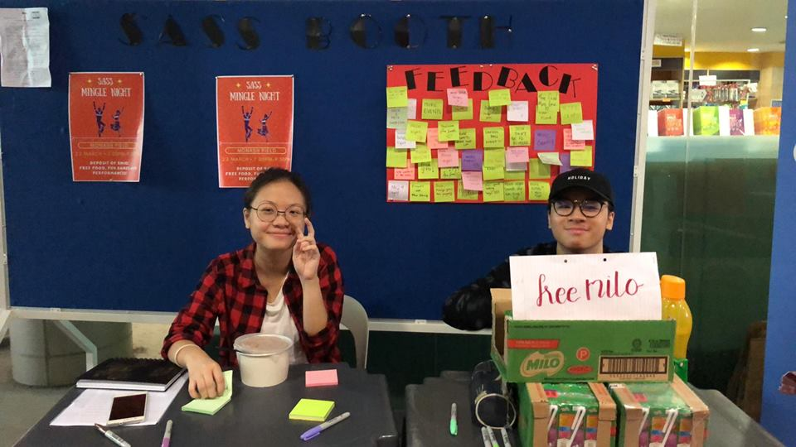

      - Milo box drinks were given out to 100 students who contributed to the booth by sharing a feedback.
      - Managed to get more than 60 SASS students to share their feedback.
      - The remaining milo box drinks were given to anybody who wanted them in exchange of their feedback.
      - Students were happy with what they received and the chance to share their thoughts!

(Student representative, Nafisa questioned the School of Arts & Social Sciences Representatives on the ways in which this event was publicized. School of Arts & Social Sciences Representative, Joshua said it was announced on their Facebook page.)

Contributed by,
Joshua and Leanne Lee
School of Arts and Social Sciences Representatives

Motion #11: Acceptance of School of Arts and Social Sciences Representatives’ Report
Accepted by: Jaesivan Arumugam
Seconded by: Kong Seng Kin, Terence

2.8 School of Business Representatives’ Report

Date: 23rd March 2018
Attention: All departments
Purpose: To inform

    - SOB x SOS Mingle Night
      - School of Business and School of Science collaborated on our Mingle Nights due to unforeseen water disruption that led to closing of campus from Friday 9th-11th March, affecting SOS’s Mingle Night originally planned on 9th March.
      - Event was held on Monday, 12th March, using both the sports centre and field, with 5 station games split between these two venues. Total of 210 students signed up, but only around 100 students showed up. Students were expected to complete each stations in their allocated groups (15 in total) to obtain a treasure hunt hint to a secret place on campus, before returning to proceed with their next station game and so forth. Each station game was allocated points based on fastest team (2 teams competing at once per round), and whether they managed to find the secret place.
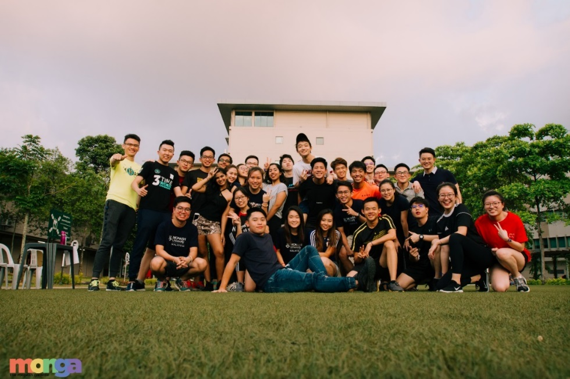
Teams at one of the station games (all smiles before and after game)

      - Had to change to plan B games after it starting raining towards the end of the games session, and by 9pm, students were served their dinner and ice cream. All students proceeded to stay inside Sports Centre for the performances from Music Club and announcement of top 3 winners from the games session. Event ended at around 11pm with participants taking group photos and creating good memories with one another.
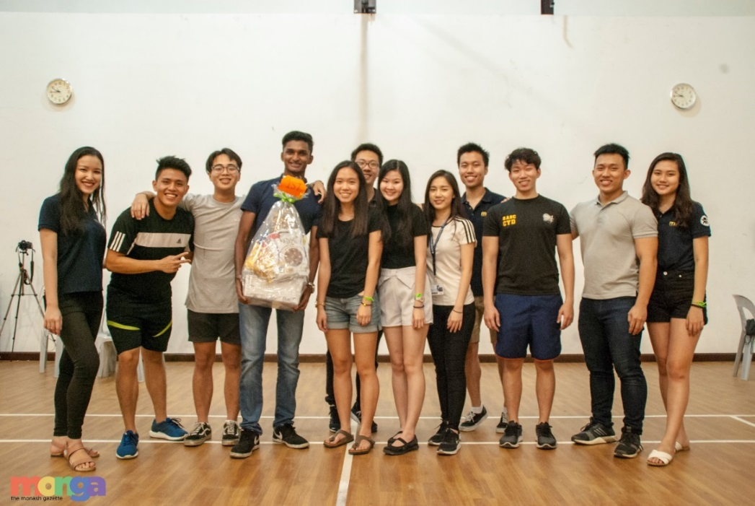
Grand Prize Winner for Games session

      - Event is a great success despite last minute changes to plans, with all participants very keen and excited to participate in games. Despite only having 100 students turn up, not much affected as food was finished and event went on smoothly, with enough participants to split into 15 groups. Big thank you to School of Science for adapting so well to our pre-planned games and event flow, Editors for great coverage of our event, and also to the Treasurers for having accommodated to our last minute cash requests. Also extremely grateful for the Music Club for sending performers to our event.
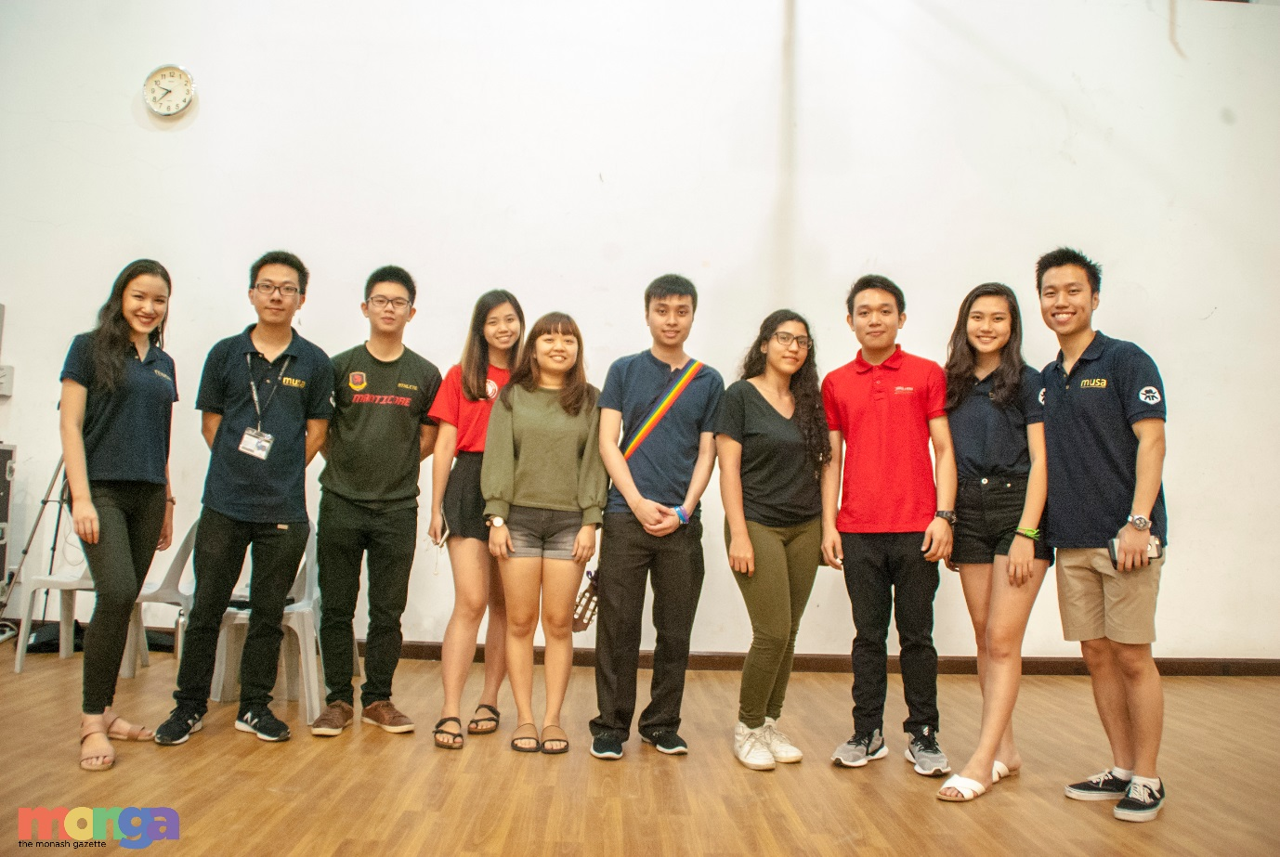
With Music Club performers

      - Many positive feedback from students to upkeep and plan more collaborative events like this.

    - Staff Student Liaison Committee (SSLC) Meeting (March 2018)
      - Main Meeting Agendas
        - Increasing the number of student representatives in SSLC.
        - We would like to increase the number of representatives to a total of 9 (currently have 4 representatives) so that each student representative can focus on a major, making it more effective.

      - Blasting out email to inform students about SSLC.
        - Have consulted CMO on this.
        - In the event that Student Experience do not allow MUSA to have the email list, we hope the committee will be able to request Student Services to blast out email to the School of Business students to inform them about the SSLC meetings.
(School of Business Representative, Zu Peng has approached Mr Zebba about the email blast and according to Mr Zebba, it can be done, provided it goes through him and he has to check the email draft first.)
Side note: MUSA should have own student email list to inform students about important matters.
      - Workshops for law subjects.
        - We suggest a research workshop for Business Law units to aid students in searching and understanding the appropriate law cases and law terms outside of the prescribed textbook to further enhance their knowledge in the subject and improve their assignment quality.

      - Feedback on the lecturers.
        - Student suggested that ECW 1101 tutors can improve the delivery of tutorial material in a way easier to be understood, by having prepared the tutorial as necessary beforehand.
        - Student suggested that MGW 1010 lecturers can improve on the delivery of her lecture to a more interactive and engaging manner/style.
(School of Business Representative, Zu Peng mentioned that Course Management Office of School of Business has announced that from this year onwards, SSLC is not the right platform for students to voice out their dissatisfaction or opinion on specific unit-related stuffs. Instead, SSLC is to discuss about the course in general.)
(Editor Terence (who is also a member of SSLC) added by saying SSLC is a platform for students to give their suggestions, ideas and inputs on how to make the course experience better in general instead of focusing on specific units. This is to avoid students from attacking specific lecturers on purpose.)
(School of Information Technology Representative, Skyler Ng mentioned that School of Information Technology gives out surveys during lectures for students to write down their ideas and he feels School of Business can practise this way too. School of Business Representative, Zu Peng said that they have thought of this idea too but it is hard to be implemented especially when School of Business has more lectures, units and lecturers.)

      - Feedback on the frequencies of SSLC meetings in a year.
        - Request to increase the frequencies of SSLC meetings in a year.

      - Feedback on course structure.
        - In the event of clashing lectures, CMO or student services usually advise students to drop and/or change to other units to resolve this. Feedback is that this has disrupted student’s plan. Any alternatives to solve this issue?
2.8.3 Ongoing Events

      - SOB T-shirt Competition.
2.8.3.1 Submissions for the competition are open from now (officially
Monday, 19th March) till Friday, 30th March, Week 5.
2.8.3.2 Winners chosen through online voting (Google forms to avoid
biasness), and will be given RM150 Gift card.

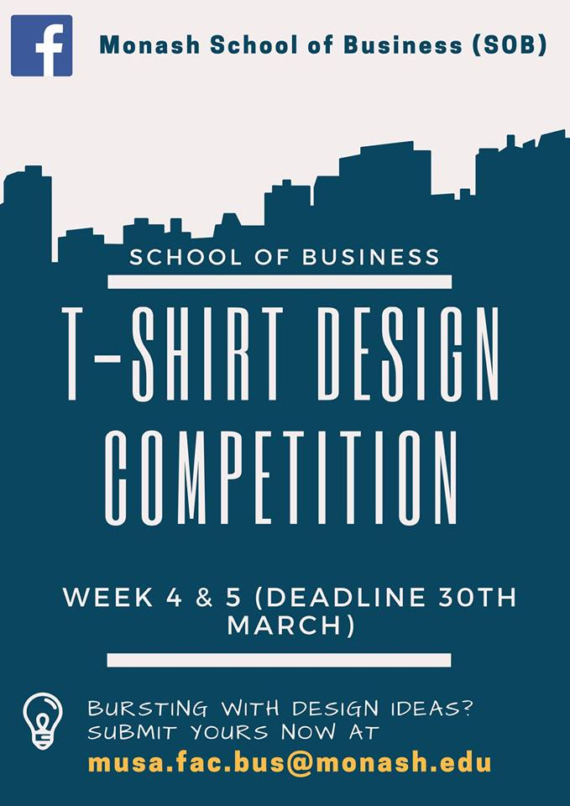
Competition promotional poster
(Editor Ling Jie asked about the participation rate for T-shirt design competitions so far. School of Business Representative, Zu Peng said it is subjective. School of Business Representative, Li San hopes more entries will come in as the prize offered is attractive. Head of Clubs and Societies, Sharik added that there were 13 to 15 submissions for School of Science T-shirt design competition last year.)

(MUISS Country Representative Officer, Charulatha asked if the T-shirt design competition is restricted only to business students. School of Business Representative, Zu Peng said it is open to all students in Monash who are interested.)

      - SOB x SOP Skytrex Trip
        - Have planned a collaborative event with School of Pharmacy to Skytrex.
        - Total of 40 participants, 20 from SOB and 20 from SOP. Event will be held on 31st March, Saturday.
        - Registration fee of RM 25 charged per participant.

Contributed by,
Soh Zu Peng and Tiong Li San
School of Business Representatives

Motion #12: Acceptance of School of Business Representatives’ Report
Accepted by: Jaesivan Arumugam
Seconded by: Nur Sharikul Huda

2.9 School of Engineering Representatives’ Report

Date: 23rd March 2018

Attention to: All departments & divisions

Purpose: To inform

    - Buddy-Buddee Night
      - Date : 15th March 2018 (Week 3, Thursday)
      - Time : 6.00pm - 9.30pm
      - Venue : Badminton court
      - There were a total of 183 students who attended this event.
      - The event started on time, at 6.45pm.
      - Everybody enjoyed the event and the feedbacks from a few of students were the games were more engaging.

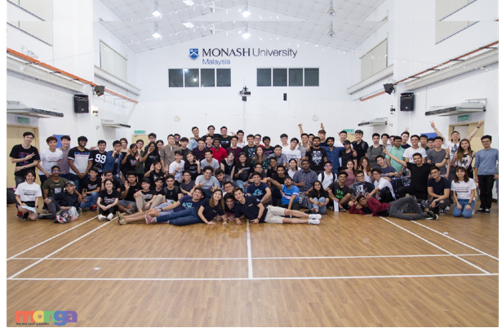

(Head of MUISS, Mazin said usually the same students are seem to be attending the events. Editor Terence said the events are usually on a first-come-first-serve basis and it is usually attended by students who are quick enough to register for the events organized.)

Contributed by,

Lim Rickque & Crystal Thew

School of Engineering Representatives

Motion #13: Acceptance of School of Engineering Representatives’ Report
Accepted by: Jaesivan Arumugam
Seconded by: Kong Seng Kin, Terence
2.10 School of Pharmacy Representatives’ Report
Date: 23rd March 2018
Attention to: All departments & divisions.
Purpose: To inform

    - T-shirt designing competition 2018
      - The competition was held for a period of 1 week from 5th March to 11th March 2018.
      - The response for design submission was quite good, in total there were 14 designs (our target was 15) and the top 5 designs were chosen to enter the final round of voting by all pharmacy students.
      - Voting period was from 13th March to 16th March 2018 which was open to all Pharmacy students.
      - The designer who won the best design will win Burgerlab vouchers worth a total of RM100.
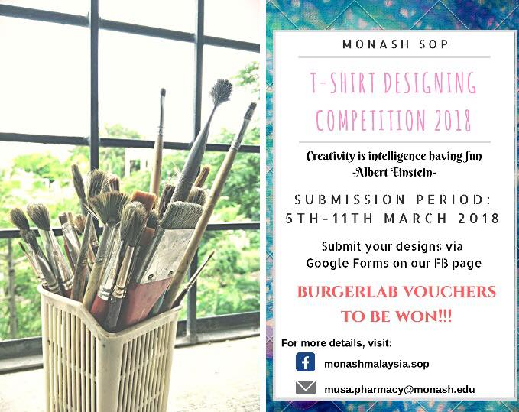
      - The winning design will be printed on our School of Pharmacy t-shirt for the year 2018.

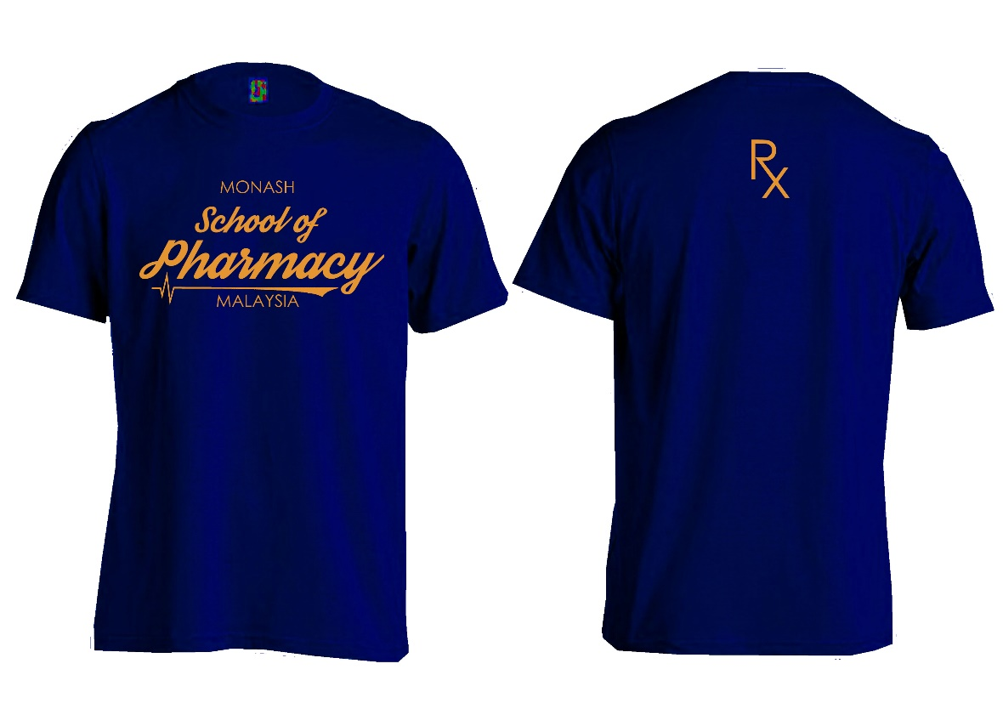

Winning design that was designed by Milton Leong Hon Kin

    - Subcommittee Recruitment
      - There were a total of 16 applicants and interviews were held for 3 days.
      - 10 applicants were successfully selected after thorough consideration.
      - The whole process was smooth.

    - Skytrex in collaboration with School of Business
      - Event will be held on 31st March 2018 (Saturday).
      - This event is opened to students from School of Business and Pharmacy and target number of participants will be 20 from business and 20 from pharmacy.
      - Students will sign up at the booth which will open from 19th March to 23rd March 2018.
      - Further updates will be reported in next MSC.
(School of Pharmacy Representative, Raymond mentioned that their SSLC is different from School of Business as Pharmacy students are allowed to voice out their opinions on the specific units as all the students in a particular year will be taking the same units. He added by saying the issues that were brought up during SSLC meeting this time were more about student academics than student welfare.)

Contributed by,
Bu Min Yee and Raymond Wong Choon Kwang
School of Pharmacy Representatives

Motion #14: Acceptance of School of Pharmacy Representatives’ Report
Accepted by: Soh Zu Peng
Seconded by: Jaesivan Arumugam

2.11 School of Science Representatives’ Report
Date: 23rd March 2018
Attention: To all departments and divisions
Purpose: To inform

    - Student-Staff Liaison Committee (SSLC) Year Representatives Recruitment
      - A recruitment post for SSLC members was published on School of Science Facebook group on 26th February 2018.
      - 14 year representatives were recruited, in which 8 SSLC members were chosen.
      - The recruited year representatives are as below:
Year | Number of Reps
1 | 3
2 | 4
3 | 2
Honours | 1

    - Science Sub-Committee Members Recruitment
      - MUSA sub-committee members recruitment post created by publicity was shared on School of Science Facebook group.
      - Interested applicants were asked to send in an email to musa.fac.sci@monash.edu to apply.
      - Interview sessions and selection were both carried out on Week 3.
      - All 20 applicants were interviewed, in which 5 members were chosen.

    - T-Shirt Design Competition
      - T-shirt design competition was moved forward to Semester 1 in conjunction with 10th year anniversary of School of Science, as suggested by School of Science Course Management Office.
      - Competition was started on 3rd March 2018 via School of Science Facebook group.
      - The theme for this year’s design is School of Science 10th year anniversary (2008-2018).
      - Submission for t-shirt designs will be closed on 23rd March 2018.
      - Most popular design will be chosen and used as the official School of Science 2018 t-shirt design.
      - Winner will receive prize of cash voucher worth RM200, in which RM100 is sponsored by Science Course Management Office.

    - SOB x SOS Mingle Night
      - Collaboration between School of Business and School of Science for Mingle Night was held on 12th March 2018.
      - School of Science Freshies’ Mingle night was originally planned on 9th March 2018, but was forced to postpone due to closure of campus from 9th to 11th March 2018.
      - Due to the changes in collaboration, students were charged RM5 of registration fee instead of RM10 refundable deposit.
      - Students were allowed to get full refund if they are unable to attend, with the receipt presented as proof.
      - 57 responses were recorded from Google form, 45 students paid for deposit.
      - 20 students requested for refund, 18 students paid RM5 registration fee and attended while 7 students did not attend nor collected their deposit.
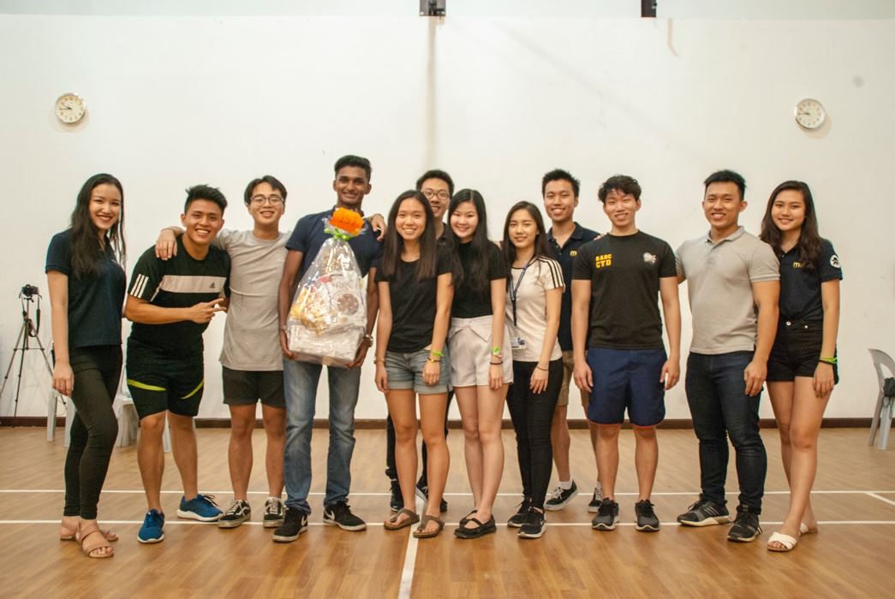
      - Registration fees and un-refunded deposit were collected as revenue.
Group picture taken with the 1st place winners

Contributed by,
Ethan Wong and Tan Yi Qi
School of Science Representatives

Motion #15: Acceptance of School of Science Representatives’ Report
Accepted by: Jaesivan Arumugam
Seconded by: Crystal Thew Xue Er

(Head of Clubs and Societies, Sharik reminded all MUSA members to be reasonable in their bookings as MUSA bookings supersedes clubs and societies’ bookings.)

(Activities Chairperson, Siemone announced that Glow Up will be held on Thursday 30th of March 2018 and it is limited to 100 people only.)

3RD MSC ADJOURNED AT 7.46 PM.

Prepared by,

Tharshini Batumalai

General Secretary

Monash University Student Association (MUSA) 2018

